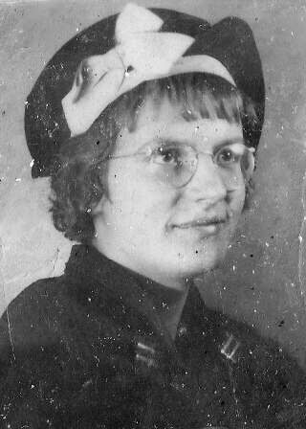

Charlotte Lichfield
October 7, 1918 – April 11, 1967
Married Ted Hays May 16, 1936

Mother of
James Edward Hays “Jimmy”
Jesse William Hays “Wessy”
Robert Joseph Hays “Little Butchie Boy”
Jean Charlene Hays “Jeanie”
John Dee Hays “Johnny”

A Collection of her poetry
Two Small Boys

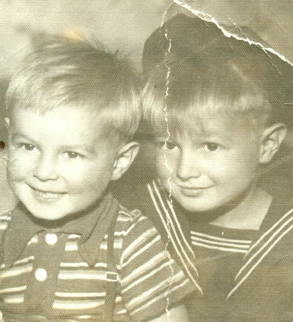

Darling, these two boys of ours
Are so sweet through all the hours
They are both so full of play
Thru the hours every day
One is dark and one is fair
They are such a perfect pair,
They’re as precious as can be
One like you and one like me
We are healthy though so poor
Yet so happy just we four
Thank you God for All the joys
That we find in two small boys

Spring 1939

Concerning Our Boys

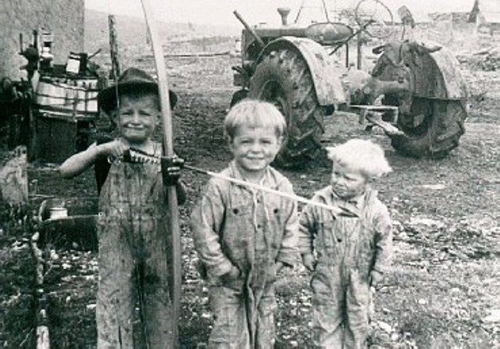

What’s a little toil and worry?”
Life’s a head, but what’s our hurry
We have naught but life to live
So let’s take the time to give
Lots of thought to our small boys
They are truly, life’s great joys.
Moneys fine but whet the race
Each of us has a given place
Let’s take a reasonable recess out
To form a plan and cast about
For a place to build our boys
And fill their lives with greatest joys.

If were poor, it doesn’t matter
Lets us try thru life to scatter
Seeds of character thru their brains
So when manhood finally reigns
WE can look at them and say
They are truly men today
We’ve not given them a noted name
One that others seek to claim
But they have a leash on life
With character to meet the strife
That comes thru life from day to day
We would have it no other way

Spring 1939
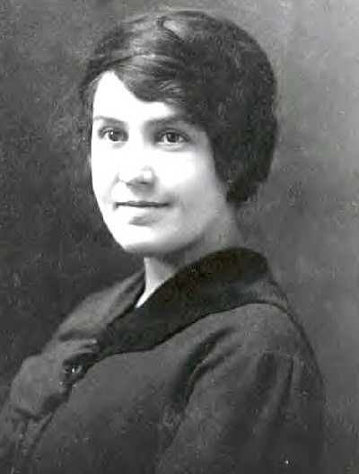

Vinna Haws Lichfield
Mother of Charlotte Lichfield Hays

To My Mother

To you dear mother I wish to say
I learn to love you more each day
You gave me ideals I can’t discard
Though I may try so very hard
Your life is such I must respect
The things in life that you’d perfect
If I can only guide my life
Through all these years of earthly strife
With such success as you have done
I’ll feel my life’s battle has been won.

Fall 1940

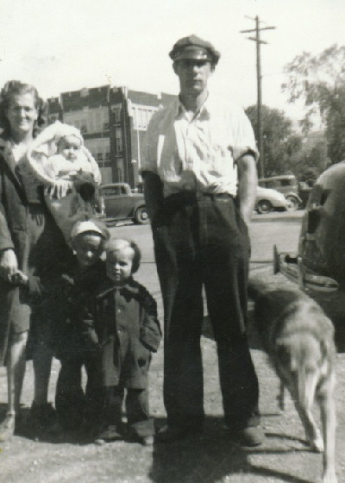

Despair

The depths of despair
Oh, what do they mean?
Am I really aware?
Or just fear the unseen

The depths of despair
Am I really so sad?
Or just a nightmare
That makes me feel bad?

The depths’ of despair
Are they really so deep?
For when trouble is rare
I fall into sleep

1940
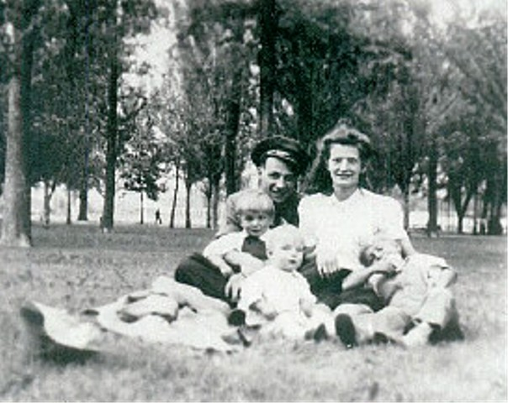

From Ted to Charlotte

I love you darling, wife of mine
Mother of these boys of mine
With your soul and heart divine
With your beauty so saintly fine

I love your eyes and hair
All your beauty beyond compare
Your features so clear and rare
Your beautiful character is always there.

I see your face wherever I go
You’re with me in whatever I do
I know you are my valentine
I hope and pray you will always be mine

Valentines Day 1939

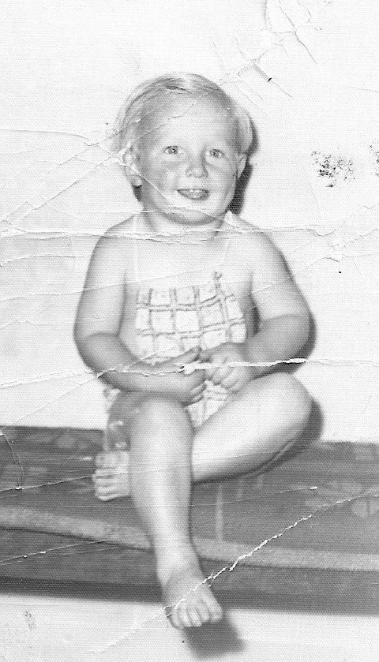

Little Butchie Boy

You’re my little Butchie boy
With your tousled yellow hair
Big blue eyes that smile
And dimples here and there
Talk about a little imp
Your angelic look belies
The deviltry that lies with in
To dimpled cheeks and two blue eyes
Two chubby legs, two chubby arms
An adorable little pot tummy
All these things rolled into one
Endear you to your mummy

Dec 8, 1941
For Bobby Hays age 2

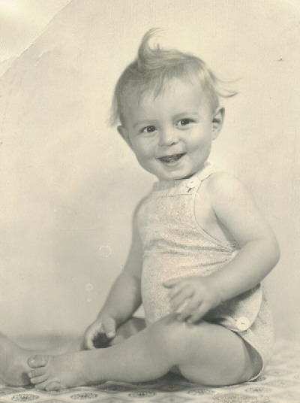

My Wessy

Two big black eyes
A sweet little nose
With a little moon face
My, how it glows

Another small imp number two of my three
Wherever there’s mischief
There you’ll find “he”,
With black eyes shinning

And dancing with glee
Oh, he is my Wessy
A darling to me

Jesse Hays at 1 year
(Jesse was three years old Dec 8, 1941 when this poem was written)

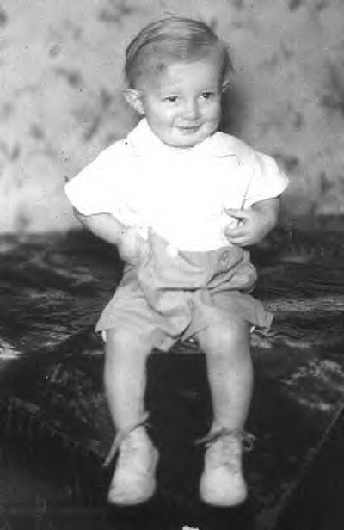

Jimmy

He’s my sturdy first born son
Such a funny little chap
Yet he seems a baby still
As he climbs into my lap

He brags of his “Big jobs”
He’s got to get to work
And he does his smallest chore
With a little smarty smirk

His tongue is quick at repartee
Although he’s only five
And with the deviltry of imps
He’s more than twice alive

And yet in times of trouble
His arms will round me fly
His sympathy and understanding
Have often made me cry

Dec 8, 1941
Jimmy was about 15 months in this picture (and five years old when this poem was written)

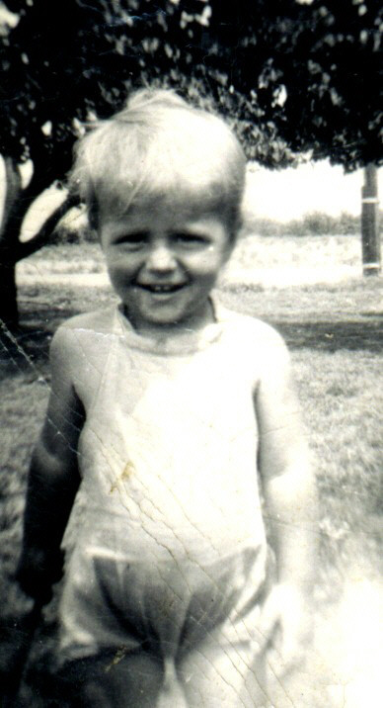

Jeanie Hays
On August 31, 1945
Charlotte give birth to her only girl

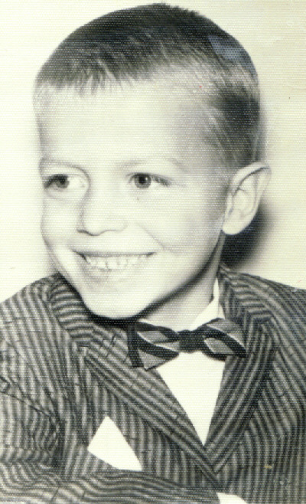

John Dee Hays
4th Son and 5th Child of Ted and Charlotte Hays
Born April 9th 1955

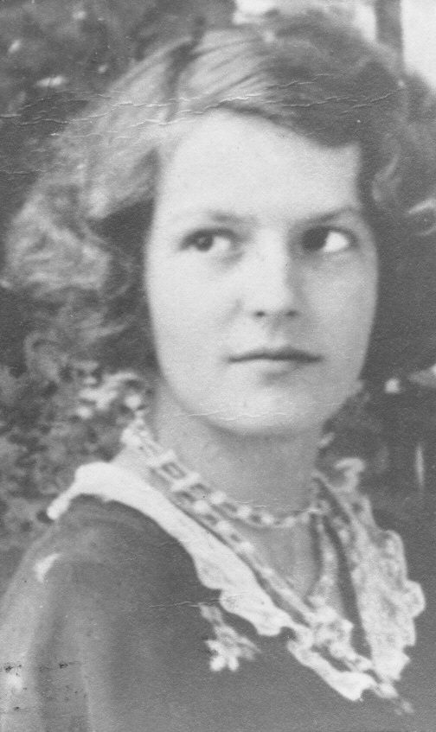

Charlotte Lichfield

Mothers Creed
Mother always used to say
There would surely come a day
When some folks ill gotten gain
Could only bring them grief and pain
When we’d complain of trial and strife
She’s say “twas all a part of life
For at the time that God made Man
Trials were formed into his plan
If we can live the Golden Rule
And in Gods hand each be a tool
What need have we of earthly means?
To help us on to Heaven’s scenes.

Fall 1940

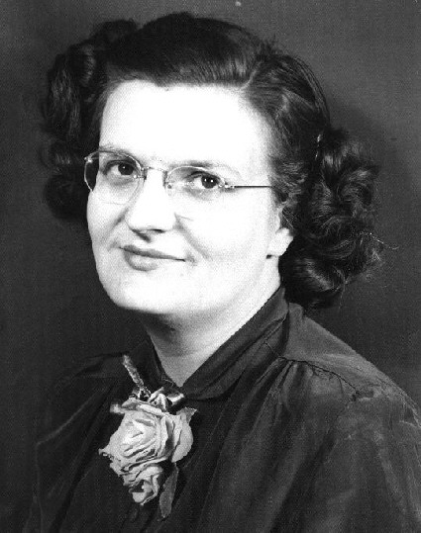
Charlotte entered and won many contests in the 1940’s and 1950’s

These are jingles for Alka Seltzer that
She sent to:
Alka Seltzer
Box 611
Elkhart, Indiana

(Apparently the prize was a 1946 Buick, she did not win)

Advantages of Buying Alka-Seltzer:

“An extra package on the shelf
Insures feeling like yourself

An Extra package when you’re fishing
Keeps you catching “stead of wishing?

An extra package when you’re drinking
Keeps your head clear for thinking

An extra package taken dry
Drink a coke Oh my Oh my

And extra package in your car
Comes in handy when traveling far.

