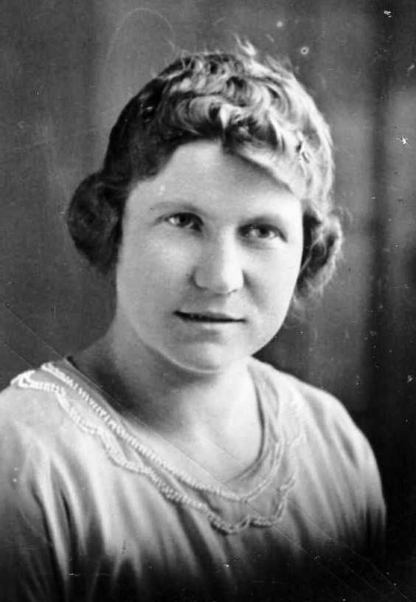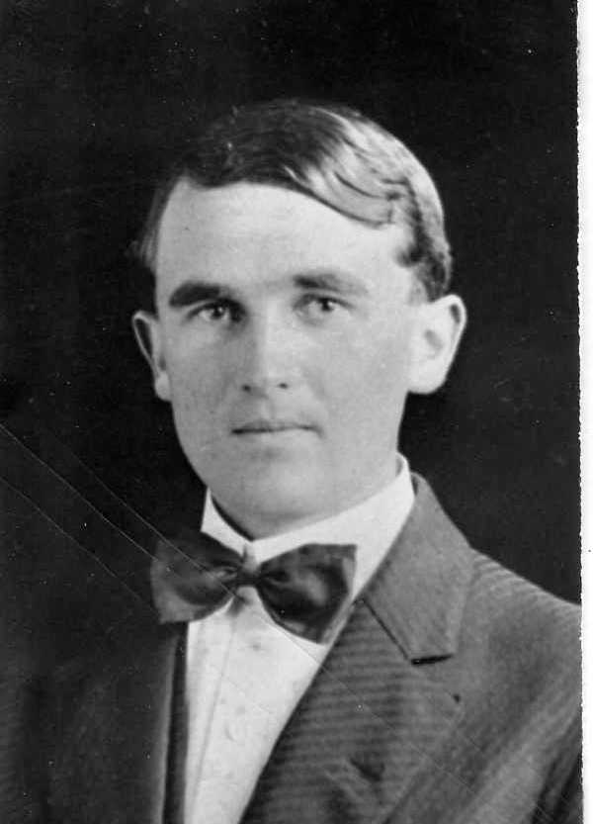
Hilda Lichfield Knudsen Walter A. Knudsen

The following account is from a June 13, 1959 Twelfth Ward Newsletter:

Here is a cheery, sparkly lady who is busier in retirement than she ever was making a living ... doing " all the things that piled up and I never had a chance to do."
Here is a person who says, and means it: " I have no patience with people who are bored ... if they are well." & "You can have what you want ... if you don't want to much".

We went to interview Mrs. Hilda Knudsen, who lives at 617 N. 8th E. We stayed to humbly listen to her philosophy, and came away with the somewhat reassuring feeling that life doesn't end by any matter of means , at retirement.

If ever anyone was a living proof of this fact, she is. On June 14, she will be 70 years old ... the bounciest, most cheerful 70 you will ever see. And apparently, no one ever enjoyed life more than she does right now.

Mrs. Knudsen has been a widow for over 40 years. He husband died three years after they were married. She retired from school teaching in 1954, after teaching 25 years at Lincoln High School in Orem and various other places before that. She lives now in a house she bought as an investment in the early 1940"s but didn't move into until nearly two years ago. She rents her basement to college boys, "wastes a lot of time on TV", does a million things for her sister, nieces and nephews and their children, and wonders where the time goes so fast.

She was born in Goshen, Utah County, but came to Provo when she was 14 to live with a widowed grandmother. Here she grew up and was married, in 1914, to Walter A Knudsen. He was a farmer, and the first year of her married life she spent on a farm near Utah Lake. But ill health, which cast its shadow over things to come, forced him to give up farming and move into Prove, where they bought a house on Fourth West. Rheumatic fever as a child had left him with a heart condition, from which he died in 1917, only three short years after they were married. Meanwhile, their only child, a son, had been born dead.

She picked up the threads of her life and enrolled at BYU, but she had gone only a quarter when a mission call came. She fulfilled the first of two missions, two years in the Northern States on Illinois.

Returning, she went to Salt Lake, enrolled in the Brown's School of Dressmaking, graduated from it, and taught at the school for two years.

Eventually she came back to the BYU, took her degree in Home Economics and taught at the university a year before embarking on a world Cruise as a student of a "floating university" which made a world tour.

Returning to Utah after a year on the cruise, she began teaching Home Economics in clothing at Lincoln High School, where she was to teach for the next 25 years until her retirement in 1954.

The retirement came a little unexpectedly. She had signed to teach another year as usual, when the second mission call came, this time to the Hawaiian Islands. She left for the Islands in 1954, returning on New Years Day of 1956.

It will be two years this August since she moved into her present home. And as she said, she keeps "busier than I have ever been doing all things I wanted to do and never could before."

A lifetime of active church work and many positions is now being climaxed by service on the Stake Primary Board, a post she has held about two years. Perhaps climaxed is the wrong word. Nothing will ever be a climax for her. She'll always find something newer and more interesting.

Some of the things "She never could do before" included a temple tour down through Mesa, Arizona and California a couple of years ago. She went alone, and had the time of her life, seeing the sights into Mexico before returning.

She sews for her nieces and nephews who have children and need her help. She baby sits for them, and "does a lot of little things which aren't very important." From listening to her and others who know her , we have a feeling nothing she does is really unimportant.

But most of All, as we came away from her home we had the thought:
"That is how we want to be at 70."

