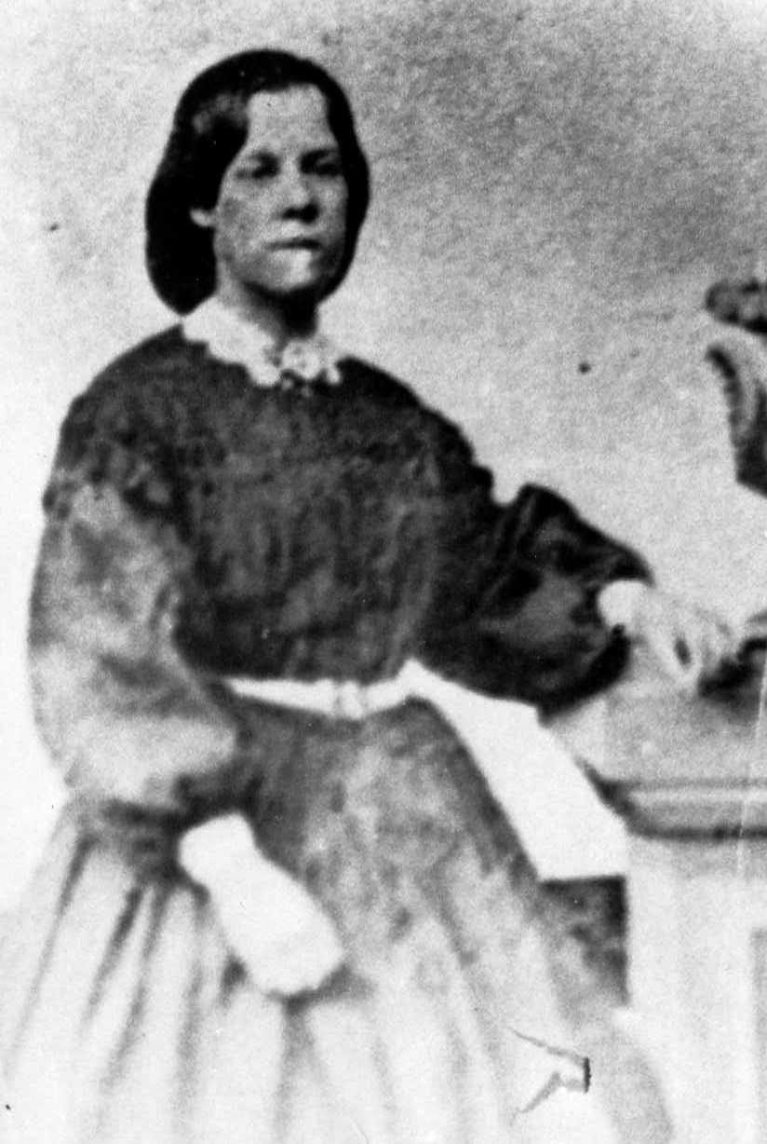

MARY ELIZABETH FRETWELL DAVIS AN AUTOBIOGRAPHY:

I saw the first light of day on the 14th of April, 1843, in London, England. My father, William Kellingly Fretwell was born February 14, 1817 in London. He received a college education and was brought up as a member of the Church of England. On May 29, 1942 he married Mary Ann Raby of Hull in Yorkshire. They were united at St. Mary’s Church in the parish of Sculcoats in Yorkshire Seven Children were the result of this union.

Mary Elizabeth April 14, 1843
Sarah Ann July 1, 1845
Emily Jane March 17, 1848
William Kellingly October 30, 1849
Thomas Unknown date 1850
Orson Pratt April 1854
John Raby August 28, 1851

My father was in a good position and we had a nice home. When I was five of six years old our family suffered some financial reverses and we had to move to poorer quarters. In order to help with living expenses, my mother learned the shoe binding trade. Since my parents were educated people they taught their children at home and we never went to public school.

During the summer of 1852 my parents lived on Glove Road, White Chapel in London. It was at this place that they first heard the gospel of Jesus Christ. I remember my Father telling of the circumstances and these are his words. “When first I heard an Elder Preach I was
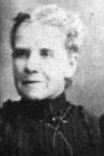

Much interested with his remarks and I believed them to be the bible truth. Myself and your mother visited several of their meetings and each one of us felt a serene and beautiful influence I became convinced that the Gospel with all its gifts and graces had indeed been restored.

At this time we were financially in distressed circumstances. My father had been out of employment for a long time and times were very hard in London. The little we had that we could part with, we sold for food. My father’s clothes were well worn and he thought if he joined the church then, in that condition, they would think he had done it just to get help from the church. My father said to my mother “There is no need of you waiting to be baptized and when I obtain work I will be baptized also.” She obeyed his council land was baptized in November 1852. A few months my father found employment and he and I were baptized in the spring of 1853 when I was ten years old.

My Father was a man who took much interest in the principles of the Gospel and delighted to converse upon them. He was a religious man and took much pleasure in talking with his children about things that pertained to eternity.

My mother often went with the Elders when they held street meetings
To help them with the singing and she always took me with her. It was during that time that a fellow by the name of Hebdon was persecuting the saints in London and he often broke up the street meetings with a mob.
My mother was a faithful Latter-day-saint and always put her whole heart and soul into her religion.

At the end of the above pages the following comments were written by her Daughter, Ethel Olive Davis Humphrey’s:

My mother had gray eyes and brown hair, till it turned a beautiful white. She was about 5 foot 5 inches tall; she and my father were about the same height. She was a sweet tempered woman and everybody loved her as they did father. She was a good singer and often sang, “Columbia, Gem of the Ocean”, “Beautiful Star” and other hymns while she sewed with an old fashioned low armed Singer sewing machine. She was nearly always sewing for somebody in the daytime and reading the Deseret news of some other literature in the evening.

When I and my two younger sisters were small, Mother taught us songs and poems. I remember her teaching us “Praise God from whom all Blessings flow” because the memory seemed to make an imprint on me all of my life. It was in the evening while we were waiting for father and brothers to come in for supper and we were sitting around the box stove with the light from the open door flickering around the room showing such a dear mother seated in her rocking chair with three little girls assembled by her. We didn’t light the lamps till they were really needed to save on coal oil.

So many memories come to mind of Mother it would be impossible for me to write them but I do feel deep gratitude for her for all she went through for her children and I the least of them caused her more anxiety..(Just prior to her birth) with me being so near her heart, when she was in poor health, and had to give up her home, brothers and friends to go in a desolate desert, wild Indian country, traveling and taking care of the rest of the family; getting meals on a campfire, and all the work required, and driving a team herself over such roads, and then in the shadow of death for my sake. Can I ever repay her? NO! But by me trying to live the kind of life she would have me live I hope she will be happy when we meet again.

She married James Davis April 23, 1864 in the Salt Lake endowment house: Pictured here…
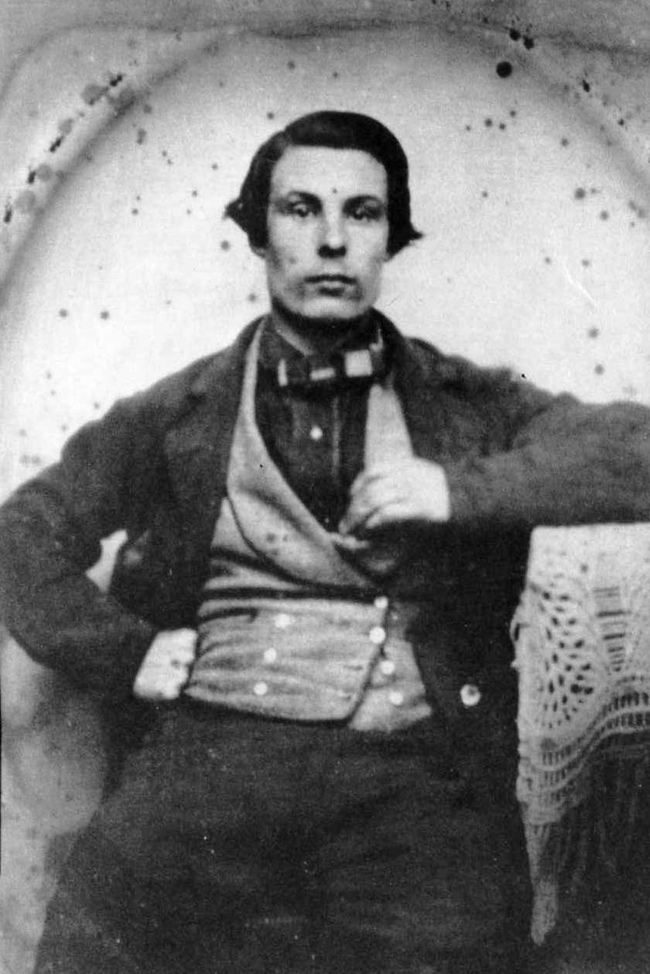

They were the parents of eleven children:

Mary Fretwell born February 7, 1865 Cedar City Utah
Edward Fretwell April 4, 1866 Cedar City, Ut
George William Fretwell October 24, 1865
James Henry Fretwell October 25, 1870
Emily Ellen June 2, 1873 Cedar City, Ut
Kate Elizabeth Jan 21, 1575 Cedar City, Ut
John Orson September 10 1876 Cedar City, Ut
Nora Jane February 231, 1878 Cedar City, Ut
Ethel Olive August 2, 1879 Montezuma, San Juan
Cordelia August 15, 1881 Montezuma, San Juan
Stella July 22, 1881 Montezuma, San Juan

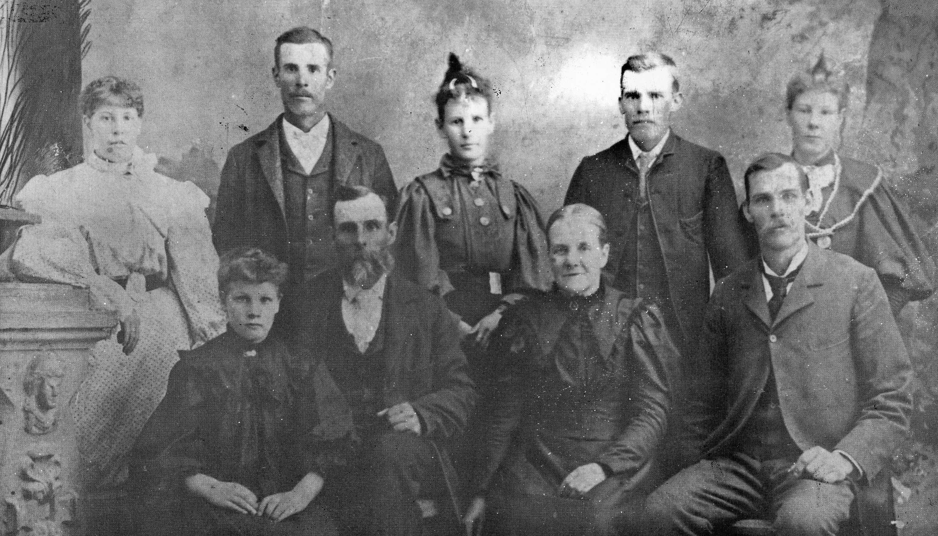

James and Elizabeth Fretwell Davis with seven of their eleven children

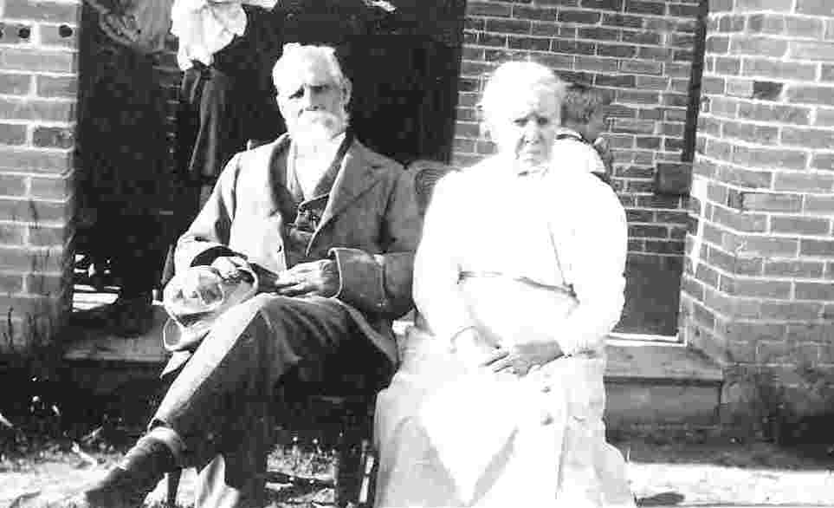
James and Elizabeth in their 80’s

